PREFIX rdf: <http://www.w3.org/1999/02/22-rdf-syntax-ns#>

PREFIX owl: <http://www.w3.org/2002/07/owl#>

PREFIX xsd: <http://www.w3.org/2001/XMLSchema#>

PREFIX rdfs: <http://www.w3.org/2000/01/rdf-schema#>

PREFIX : <http://www.semanticweb.org/simen/ontologies/2014/9/infovitFINAL#>

1#Displays all possible subjects in BASV-INFO-program

SELECT ?subject

WHERE {

{?subject rdfs:subClassOf :Choice. }

UNION

{?subject rdfs:subClassOf :Exphil.

}

UNION

{?subject rdfs:subClassOf :Introduction.

}

UNION

{?subject rdfs:subClassOf :Specialization.

}

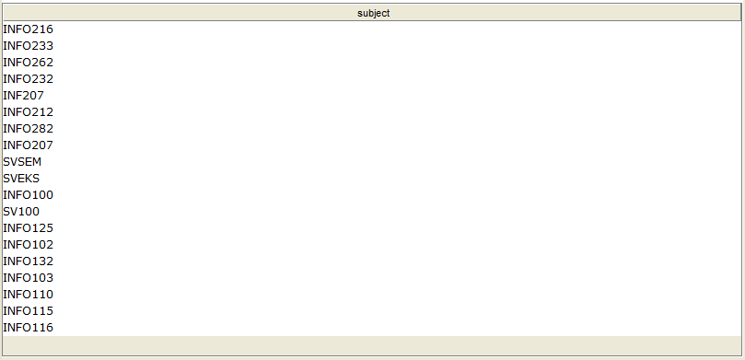

2#Which ones has programming

SELECT ?subjName

WHERE {

?subjName :covers :Programming.

}

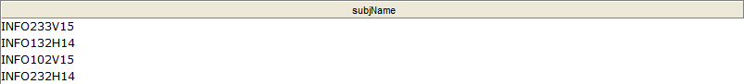

3#Covers databases but NOT querylanguage

SELECT ?subjName

WHERE {

{?subjName :covers :Database} MINUS {?subjName :covers :Theory}

}



4#How many groupprojects or mandatoryAssignements

SELECT ?courseName ?groups ?assignments

WHERE {

{?groups a :GroupProject.

?courseName :has ?groups}

UNION

{?assignments a :MandatoryAssignments.

?courseName :mustComplete ?assignments

}

}

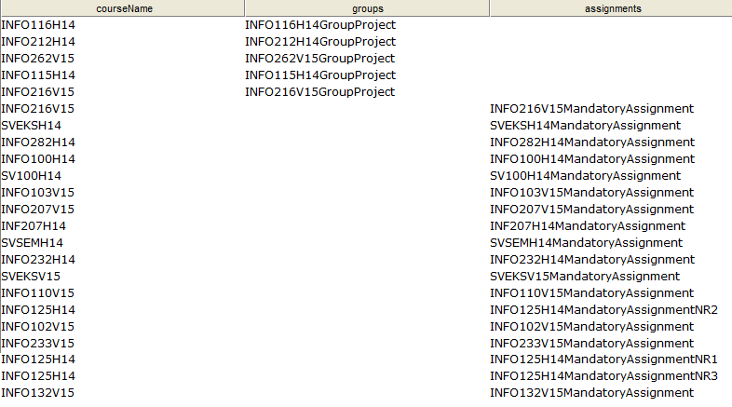

5#Which courses are at autumn

SELECT ?courseName

WHERE {

?courseName :isAt :Autumn .

}

ORDER BY ?courseName

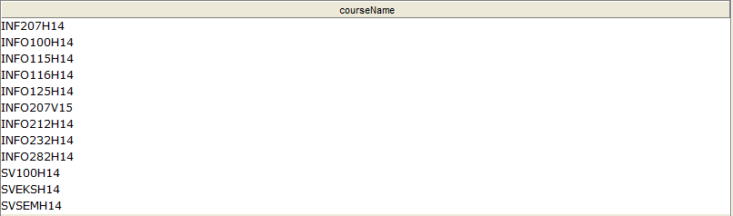

6#Covers any of them both OOP and algorithms

SELECT ?subjName

WHERE {

?subjName :covers :Algorithms .

?subjNm :covers :Data-Architecture .

FILTER (?subjName = ?subjNm)

}



7#All courses at spring with 10 studypoints

SELECT ?subject

WHERE {

?subject :isAt :Spring;

:has :STC10.

}

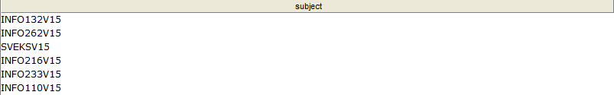

8#Which subject areas do you learn from the course

SELECT ?subjArea

WHERE {

?subjArea a :Subject-Areas .

?subject :covers ?subjArea.

FILTER(?subject = :INFO110V15)

}



9#All courses that are in English

SELECT ?subjName

WHERE {

?subjName :is :English .

}

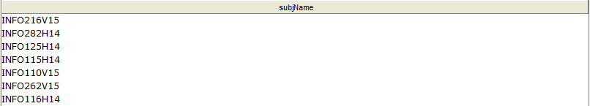

10#Which ones has programming at Spring

SELECT DISTINCT ?subjName

WHERE {

{?subjName :covers :Programming} UNION {?subjName :isAt :Spring.}

}

ORDER BY ?subjName

